***Functionalities of, Primeflix(Like Netflix) the application itself and the other one is customer.***

1. Sign-up/register(using phone number email id ) verification done by otp.

2. Create a profile (add name to profile) add various restrictions.

Eg. Kids account(for watching the cartoons ),adult account.

3. Show various subscription models (according to the number of screens required).

4. Display various offers on the subscription (offers on specific cards).

5. Showing trending movies and series to attract users.

6. Now they have introduced new sections such as fast laugh (includes comedy clips from various movies and series and due to this if that particular user haven’t seen that series or movie than he or she sees that movie/series).

7. Introducing amazing games on their portal(indirectly showing ads of games {here another source of income is generated}).

8. Allows a user to create their own list of series and movies so they can watch easily whenever they want and it also helps to attract new user indirectly (Eg. We would recommend our friend to watch our list of series and movies).

Netflix from customer end

1. It provide the user a feeling of premium-ness
2. After the user sign-up/login it shows most trending movies and series (this is nothing but most watched by the users
3. It provides different sections according to the user likes and dislikes.
4. It provides easy and amazing user interface to keep the use interact.
5. It gives an option of download (in-case user not having internet connectivity)
6. It gives the user an option for like and dislike (which makes the user feel good and it makes the user feel that its reaction is important for Netflix).
7. It provides amazing streaming configuration so that users not much internet is used

**Database Tables**

1. User name/profile
2. Profile type (kids/adult)
3. User subscription details
4. Series type details
5. Movie details table
6. Fast laugh table (cuts from movies and series which are comedy)
7. Game details table
8. Account detail
9. Series and movies with different languages

**UI Prototype**

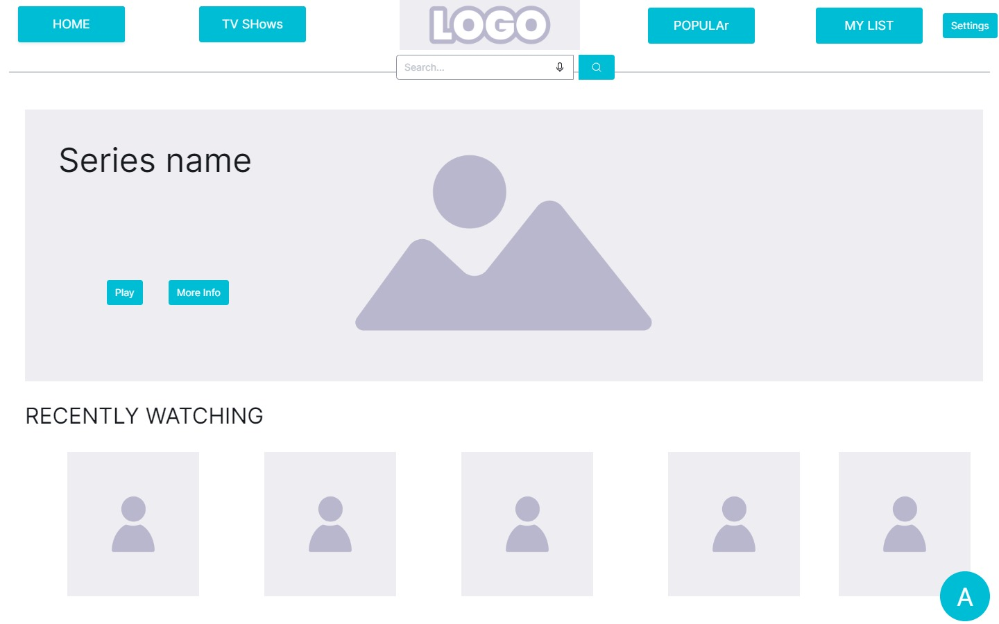

**2.Profile**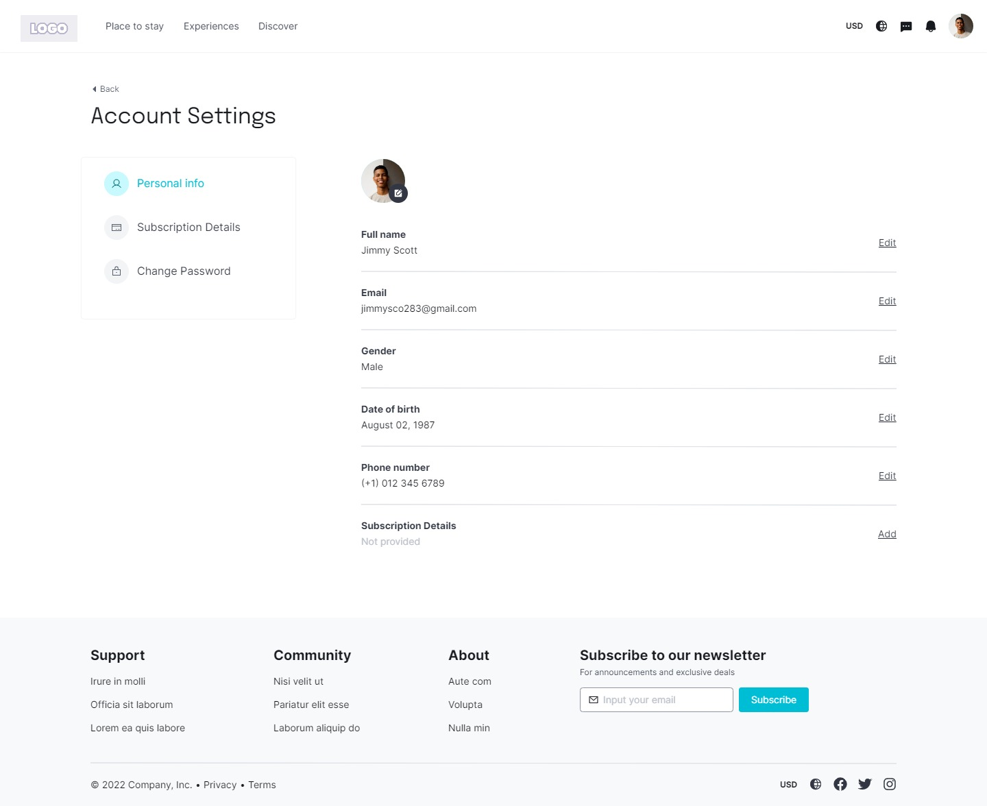

**3.Signup**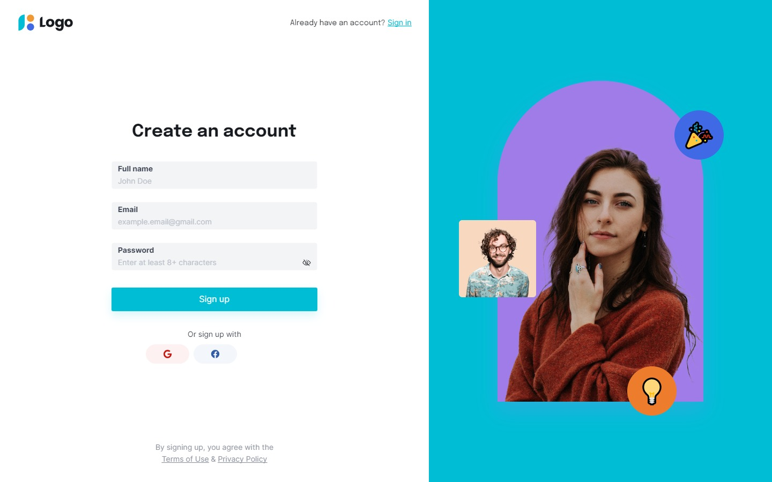

**4.After opening any series/show**